DAY-13 - C/C++ PROGRAMMING - HARSHINIE M

/*
Purpose : Write a C++ program to demonstrate multithreading using std::thread,
where one thread continuously prints '0' and the main thread
continuously prints 'X'.
Author : Harshinie M
Date : 08-01-2026
*/

#include <iostream>
#include <thread>

// Function that will run in a separate thread
void funOne()
{
while (1)
{
std::cout << "0";
}
}

int main()
{
// Create a thread object and start funOne()
std::thread t1(funOne);

// Main thread prints 'X'
while (1)
{
std::cout << "X";
}

// Good practice (never reached due to infinite loop)
t1.join();

return 0;
}

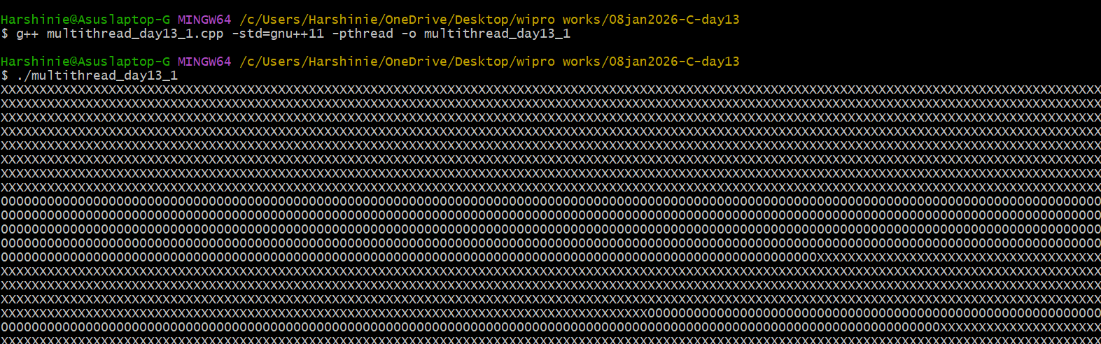
/*
Purpose : Write a C++ program to demonstrate multithreading using std::thread,
where one thread prints '0' 100 times and the main thread prints
'X' 100 times.
Author : Harshinie M
Date : 08-01-2026
*/

#include <iostream>
#include <thread>

// Function that will run in a separate thread
void funOne()
{
for (int cnt = 0; cnt < 100; cnt++)
{
std::cout << "0";
}
}

int main()
{
// Create a thread object and start funOne()
std::thread t1(funOne);

// Main thread prints 'X' 100 times
for (int cnt = 0; cnt < 100; cnt++)
{
std::cout << "X";
}

// Wait for thread t1 to finish
t1.join();

return 0;
}

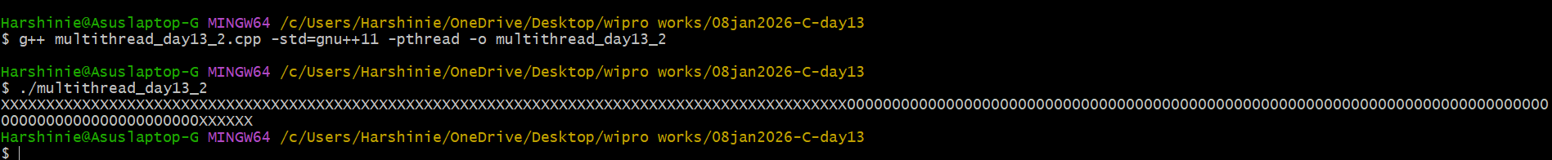

/*
Purpose : Write a C++ program to demonstrate multithreading using std::thread
with a lambda expression.
Author : Harshinie M
Date : 08-01-2026
*/

#include <iostream>
#include <thread>

int main()
{
// Create a thread using a lambda expression
std::thread t1([] {
std::cout << "Inside lambda here" << std::endl;
});

// Code executed by the main thread
std::cout << "In main()" << std::endl;

// Wait for thread t1 to finish execution
t1.join();

return 0;
}

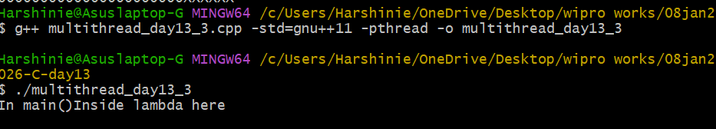

/*
Purpose : Write a C++ program to demonstrate the use of detach() in multithreading,
where a thread prints '0' 100 times and runs independently from main(),
while the main thread prints 'X' 100 times.
Author : Harshinie M
Date : 08-01-2026
*/

#include <iostream>
#include <thread>

// Function that will run in a separate thread
void funOne()
{
for (int cnt = 0; cnt < 100; cnt++)
{
std::cout << "0";
}
}

int main()
{
// Create a thread object and start funOne()
std::thread t1(funOne);

// Detach the thread (runs independently)
t1.detach();

// Main thread prints 'X' 100 times
for (int cnt = 0; cnt < 100; cnt++)
{
std::cout << "X";
}

return 0;
}

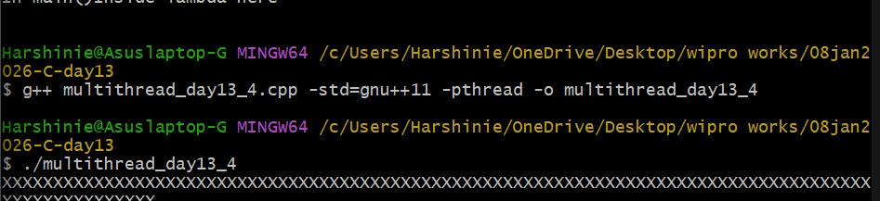

/*
Purpose : Write a C++ program to demonstrate creation of multiple threads
and pausing their execution using sleep_for() from <chrono>.
Author : Harshinie M
Date : 08-01-2026
*/

#include <iostream>
#include <thread>
#include <chrono>

// Function executed by each thread
void fun()
{
std::cout << "fun() called" << std::endl;

// Pause the current thread for 1 second
std::this_thread::sleep_for(std::chrono::seconds(1));
}

int main()
{
// Create multiple threads executing the same function
std::thread t1(fun);
std::thread t2(fun);
std::thread t3(fun);
std::thread t4(fun);
std::thread t5(fun);

// Wait for all threads to complete
t1.join();
t2.join();
t3.join();
t4.join();
t5.join();

return 0;
}

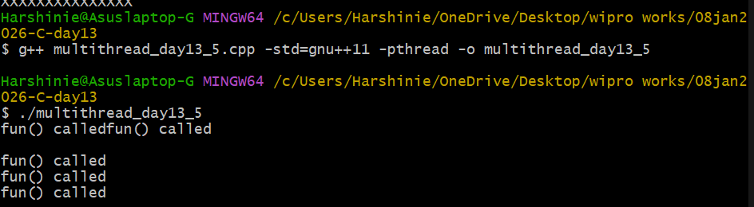

/*
Purpose : Write a C++ program to demonstrate creation of a thread using
a function object (functor).
Author : Harshinie M
Date : 08-01-2026
*/

#include <iostream>
#include <thread>

// Class with function call operator (functor)
class Test
{
public:
void operator()()
{
std::cout << "Thread from Test" << std::endl;
}
};

int main()
{
// Create an object of Test class
Test obj;

// Create a thread using function object
std::thread t1(obj);

// Main thread execution
std::cout << "Thread from main()" << std::endl;

// Wait for thread t1 to complete
t1.join();

return 0;
}

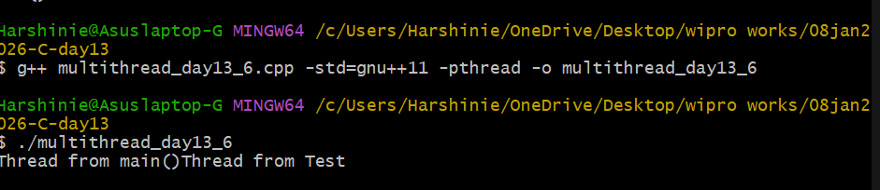

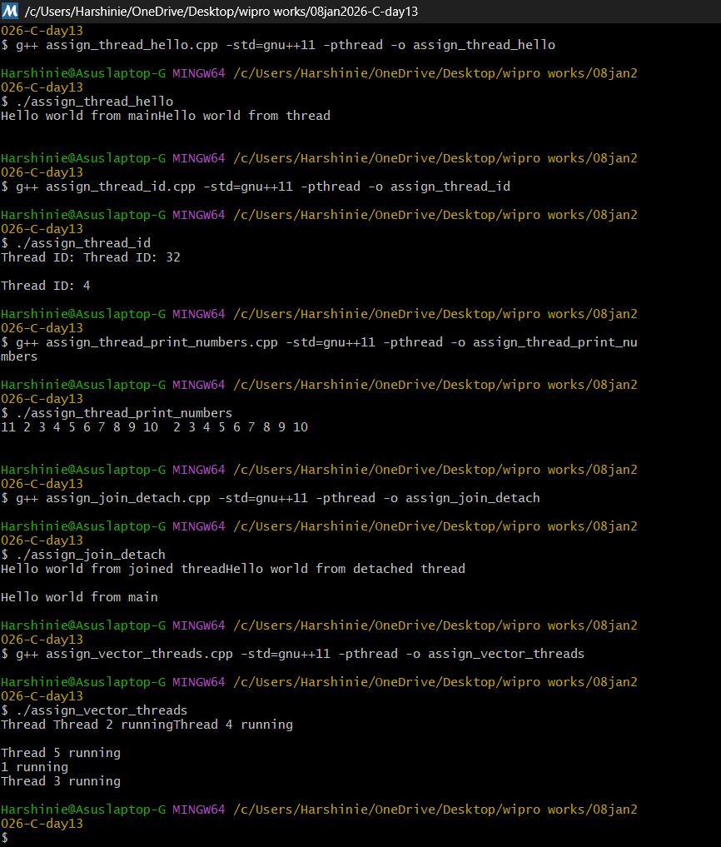
Above are output for assignment programs.

/*
Purpose : Write a C++ program to demonstrate passing arguments to a thread
function using std::thread.
Author : Harshinie M
Date : 08-01-2026
*/

#include <iostream>
#include <thread>

// Function executed by the new thread
void funOne(int arg)
{
std::cout << "New Thread: " << arg << std::endl;
}

int main()
{
// Create a thread and pass argument to the function
std::thread t1(funOne, 100);

// Code executed by main thread
std::cout << "Main Thread:" << std::endl;

// Wait for thread to complete
t1.join();

return 0;
}

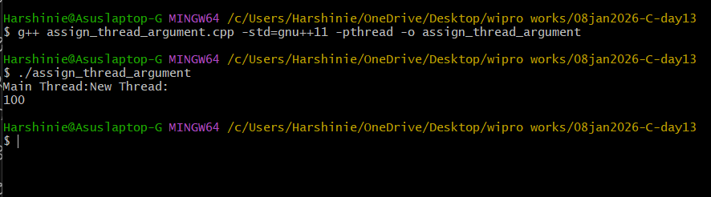

/*
Purpose : Write a C++ program to demonstrate thread synchronization using
std::mutex to safely update a shared global variable.
Author : Harshinie M
Date : 08-01-2026
*/

#include <iostream>
#include <thread>
#include <mutex>

int globVar = 0; // Shared global variable
std::mutex mVar; // Mutex to protect shared resource

// Function executed by threads
void Update()
{
// Lock the mutex before accessing shared resource
mVar.lock();

for (int cnt = 0; cnt < 100000; cnt++)
globVar++;

// Unlock the mutex after work is done
mVar.unlock();
}

int main()
{
// Create two threads
std::thread t1(Update);
std::thread t2(Update);

// Main thread also updates the shared variable
mVar.lock();
for (int cnt = 0; cnt < 100000; cnt++)
globVar++;
mVar.unlock();

// Wait for child threads to complete
t1.join();
t2.join();

// Print final value of global variable
std::cout << "global var: " << globVar << std::endl;

return 0;
}

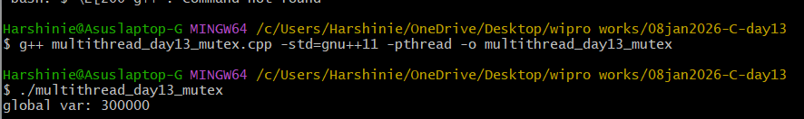

/*
Purpose : Create a C++ program to fill a global array of 100 elements using
5 threads, where each thread fills exactly 20 elements.
Author : Harshinie M
Date : 08-01-2026
*/

#include <iostream>
#include <thread>

int arr[100]; // Global array of size 100

// Function to fill array elements
void fillArray(int startIndex, int count, int value)
{
for (int i = startIndex; i < startIndex + count; i++)
{
arr[i] = value;
}
}

int main()
{
// Create 5 threads, each filling 20 elements
std::thread t1(fillArray, 0, 20, 1); // index 0–19
std::thread t2(fillArray, 20, 20, 2); // index 20–39
std::thread t3(fillArray, 40, 20, 3); // index 40–59
std::thread t4(fillArray, 60, 20, 4); // index 60–79
std::thread t5(fillArray, 80, 20, 5); // index 80–99

// Wait for all threads to complete
t1.join();
t2.join();
t3.join();
t4.join();
t5.join();

// Print the array contents
std::cout << "Array elements:\n";
for (int i = 0; i < 100; i++)
{
std::cout << arr[i] << " ";
}
std::cout << std::endl;

return 0;
}

